1. **Which are the top three variables in your model which contribute most towards the probability of a lead getting converted?**

Ans : The Top 3 variables in our model which contribute most towards the probability of a lead getting converted are following :

* Total time spent on the website
* Total Visit
* Do Not email   
  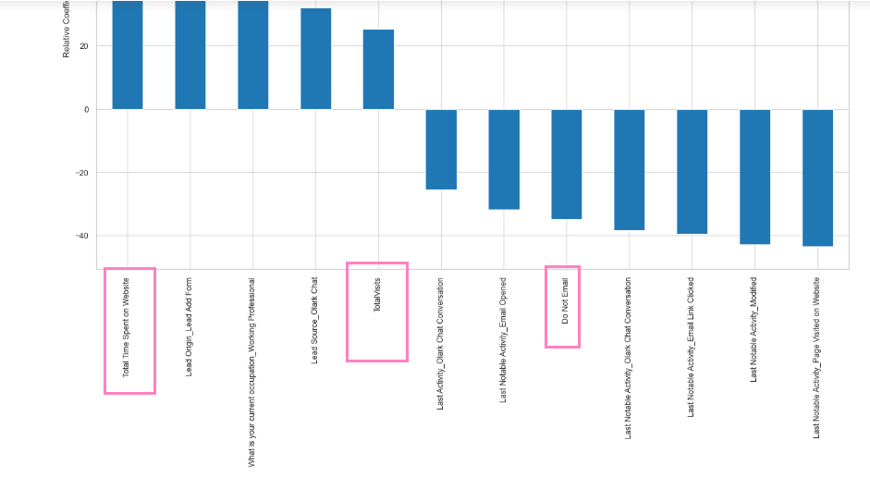

1. **What are the top 3 categorical/dummy variables in the model which should be focused the most on in order to increase the probability of lead conversion?**

Ans :

* Lead Origin_Lead Add Form
* What is your current occupation_Working Professional
* Lead Source_Olark Chat

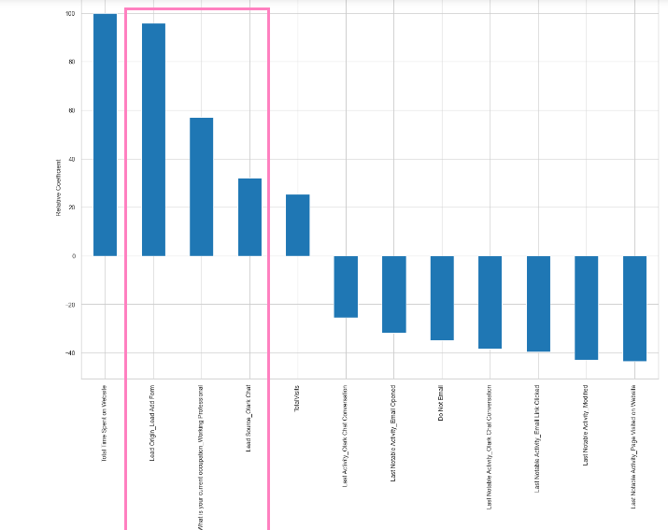

1. **X Education has a period of 2 months every year during which they hire some interns. The sales team, in particular, has around 10 interns allotted to them. So during this phase, they wish to make the lead conversion more aggressive. So they want almost all of the potential leads (i.e. the customers who have been predicted as 1 by the model) to be converted and hence, want to make phone calls to as much of such people as possible. Suggest a good strategy they should employ at this stage.**

Ans : After Analyzing the result in EDA our new intern must approach to the people by phone calls by checking

1. Students with “Landing Page Submission” as Lead Origin
2. Students Leads generated form “Google” has a high possibility of conversion
3. Students detected with “Last Activity” as “SMS Sent”
4. Company should take calls to the “Unemployed” category as they are most likely to be converted

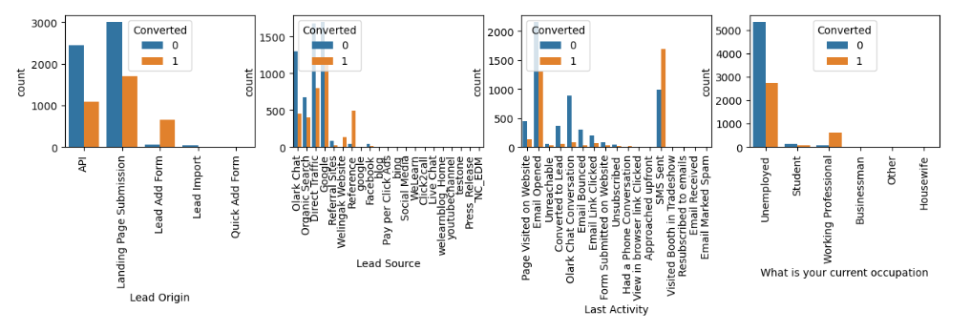

1. **Similarly, at times, the company reaches its target for a quarter before the deadline. During this time, the company wants the sales team to focus on some new work as well. So during this time, the company’s aim is to not make phone calls unless it’s extremely necessary, i.e. they want to minimize the rate of useless phone calls. Suggest a strategy they should employ at this stage.**

Ans : below are few strategies which company can take in this situation

* Company needs to focus on SMS sent & Autogenerated emails rather phone calls
* The above strategy which can be used but a customer segment having high chance of buying the course
* Leads who have applied “Do not email” already, does not need to be attended again
* If the Lead conversion is found as “Might be “ or “Worse” then those leads can be ignored
* Priority can be given based on Lead Score , Target should be >80% Lead score